**MYSQL ASSIGNMENT 4**

**Table: Sales**

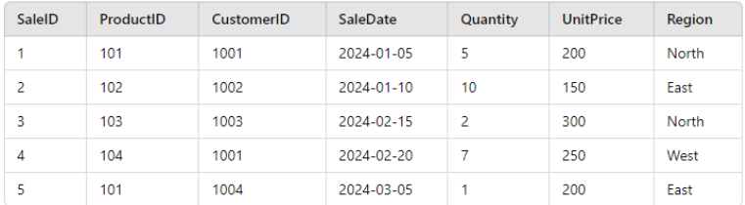

create table Sales(

SalesID int primary key,

ProductID int,

CustomerID int,

SaleDate int,

Quantity int,

UnitPrice int,

Region varchar(50)

);

insert into Sales(SalesID, ProductID, CustomerID, SaleDate, Quantity, UnitPrice, Region)

values (1, 101, 1001, 2024-01-05, 5, 200, "North"),

(2, 102, 1002, 2024-01-10, 10, 150, "East"),

(3, 103, 1003, 2024-02-15, 2, 300, "North"),

(4, 104, 1001, 2024-03-05, 7, 250, "West"),

(5, 101, 1004, 2024-03-05, 1, 200, "East");

select * from Sales;

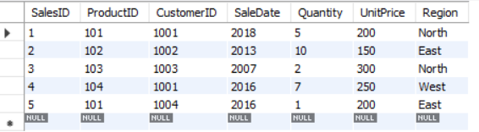

#1. Write a query to calculate the total sales (Quantity * UnitPrice) for each product.

select ProductID, SUM(Quantity*UnitPrice) as "total sales" from sales group by ProductID;

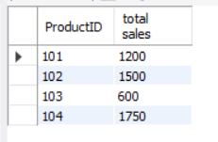

#2. Write a query to find the total number of products sold in each region

select Region, sum(Quantity*UnitPrice) As "total sales" from sales group by Region;

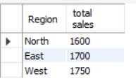

#3. Write a query to get the average sales amount per product.

select ProductID, avg(Quantity * UnitPrice) as "sales amount" from sales group by productID;

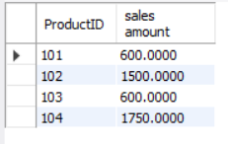

#4. Find the regions where total sales are more than 3000.

select region, sum(Quantity * UnitPrice) from sales group by region having SUM(Quantity * UnitPrice) > 3000;

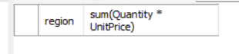

#5. Write a query to get the maximum quantity sold for each product.

SELECT ProductID, MAX(Quantity) AS MaxQuantitySold FROM Sales GROUP BY ProductID;

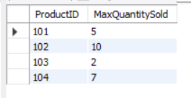

#6. Write a query to calculate the average quantity of products sold per region.

select ProductID, avg(Quantity) from sales group by ProductID;

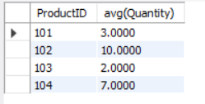

#7. Find the product IDs that have generated a total sales amount of more than 1000.

select ProductID, MIN(Quantity * UnitPrice) from sales group by ProductId Having SUM(Quantity * UnitPrice) > 1000;

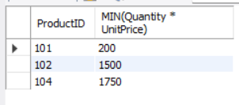

#8. Write a query to get the total number of sales (rows) made for each customer.

select CustomerID, Count(salesID) from sales group by CustomerID;

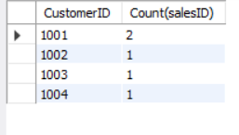

#9. Find the products for which the average quantity sold is less than 5.

select ProductID, avg(Quantity) from sales group by ProductID Having avg(Quantity) <5;

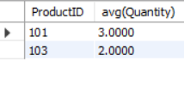

#10. Write a query to find the sum of total sales for each customer in each region.

select CustomerID,region, SUM(Quantity*UnitPrice) from sales group by CustomerID, Region;

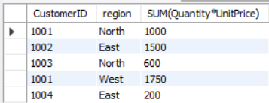

#11. Write a query to calculate the total sales for each month.

SELECT EXTRACT(MONTH FROM SaleDate) as month, sum(Quantity * UnitPrice) as "Total Sales" from Sales GROUP BY EXTRACT(MONTH FROM SaleDate);

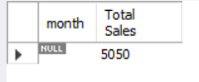

#12. Find the regions where the average unit price is more than 200.

SELECT Region, avg(UnitPrice) as "average unit price" from Sales GROUP BY Region HAVING avg(UnitPrice) > 200;

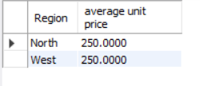

#13. Write a query to get the minimum and maximum quantity sold per region.

SELECT Region, min(Quantity), max(Quantity) from Sales GROUP BY Region;

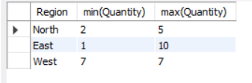

#14. Find the customers who have made more than 2 purchases.

SELECT CustomerID, count(ProductID) from sales group by CustomerID having count(ProductID) > 1;

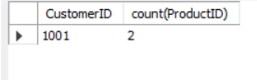

#15. Write a query to find the total sales for each product and filter only those products where the total sales exceed 1500.

SELECT ProductID, sum(Quantity * UnitPrice) as "total sales" from Sales GROUP BY ProductID HAVING sum(Quantity * UnitPrice) > 1500;

